

**SOFTWARE PROJECT 1 REPORT**

**GROUP NAME: LET’S GO**

**GROUP MEMBER :**

**Md Mehedi Hasan Naim -> 212-15-14721**

**Md Shafiul Islam -> 212-15-14716**

**Md Majedur Rahman -> 212-15-14708**

**Parvej Khan Odud -> 212-15-14742**

**SUBMITTED TO:**

**Md. Hafizur Rahman Arfin**

**Daffodil International University**

**Project name:**  “**LET’S GO”**

**Short Description:** As we worked on a tourist guide application, we keep features which are undoubtedly important to make this application user friendly. Basically, we did it’s frontend by using figma. Firstly, we use the sign in page ,then we give some instructions for the user. Then, we give a lot of user-friendly options in the application's home page such as: destination searching option. Users can see & update their profile. Also, they can select their tour guides and we show the guide's rating on their performance as a guide that undoubtedly helps customers to select his/her guide. We also add locations,descriptions and pictures of most attractive tourist spots.

**Frontend:**  We use figma to complete our frontend. We try to give a user-friendly interface in frontend.

**Backend:** Work of API’s is given bellow:

GET=The GET method is used to retrieve data from the server.

POST=The POST method sends data to the server and creates a new resource.

PUT=The PUT method is most often used to update an existing resource.

DELETE=The DELETE method is used to delete a resource specified by its URI.

Our application’s backend design:

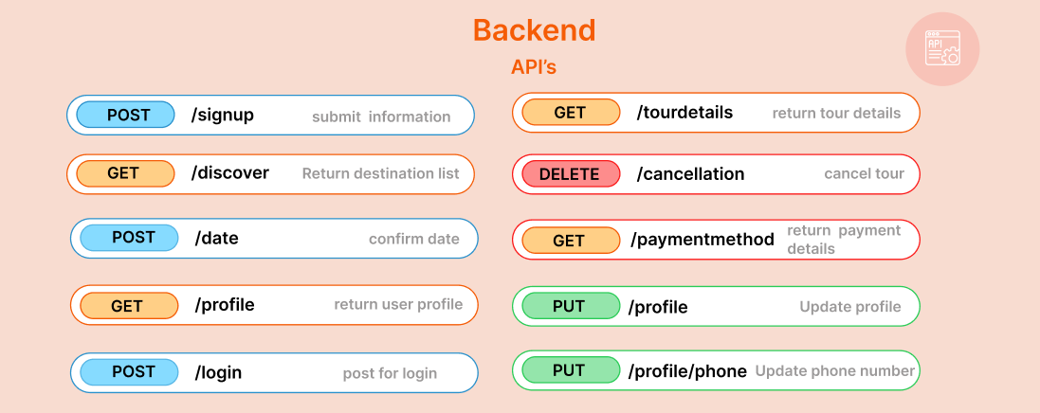

**(i)/signup:** If user fills up and submit informations of signup page then it ‘ll be a post request as the user is giving his/her information.



**(ii)/discover:** If a user clicks on a destination option then it ‘ll return a list of destinations. As using is watching the destination list so,it's a GET request.



**(iii)/date:** As the user is giving date & time,it’s a POST request.



**(iv)/profile:** As the user is requesting to show profile, it's a GET request.



**(v)/login:** As the user is giving his information to login so it’s a POST request.



**(vi)/tourdetails:** As the user is requesting for tour details, so it’s a GET request.



**(vii)/cancellation:** As the user is requesting for canceling his/her tour, so it’s a DELETE request.



**(viii)/paymentmethod:** As the user is requesting to see the payment method, so it’s a GET request.



**(ix)/profile:** As the user is requesting to update his/her profile, so it’s a PUT request.



**(x)/profile/phone:** As the user is requesting for update his/her phone number, so it’s a PUT request.



**Database:**

**Table 1:**  Here we store customer’s information. Customer id,email is primary key here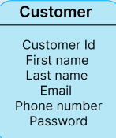

**Table 2:** Here customer id and guide id is primary key and booking id is foreign key.

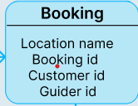

**Table 3:** This table is for payment methods. User can choose credit Card,mastercard or others options to complete payment process.

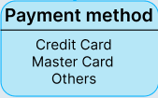

**Table 4:** This table represents necessary information for service. We need to know the location of the place and time. Also we need to know booking id, customer id, guide id ,gift code and it’s quantity.

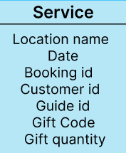

**Table 5:** In this table we use gift code and product .

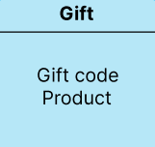

**Relation Between Tables:** One customer can have multiple orders,payment methods. That’s why the relation between “Customer table” & “payment table” is one to many.

The relation between “customer table” and “booking table” is one to many. The relation between “booking table” and “service table” is one to one. The relation between “service table” and “gift table” is many to many.

